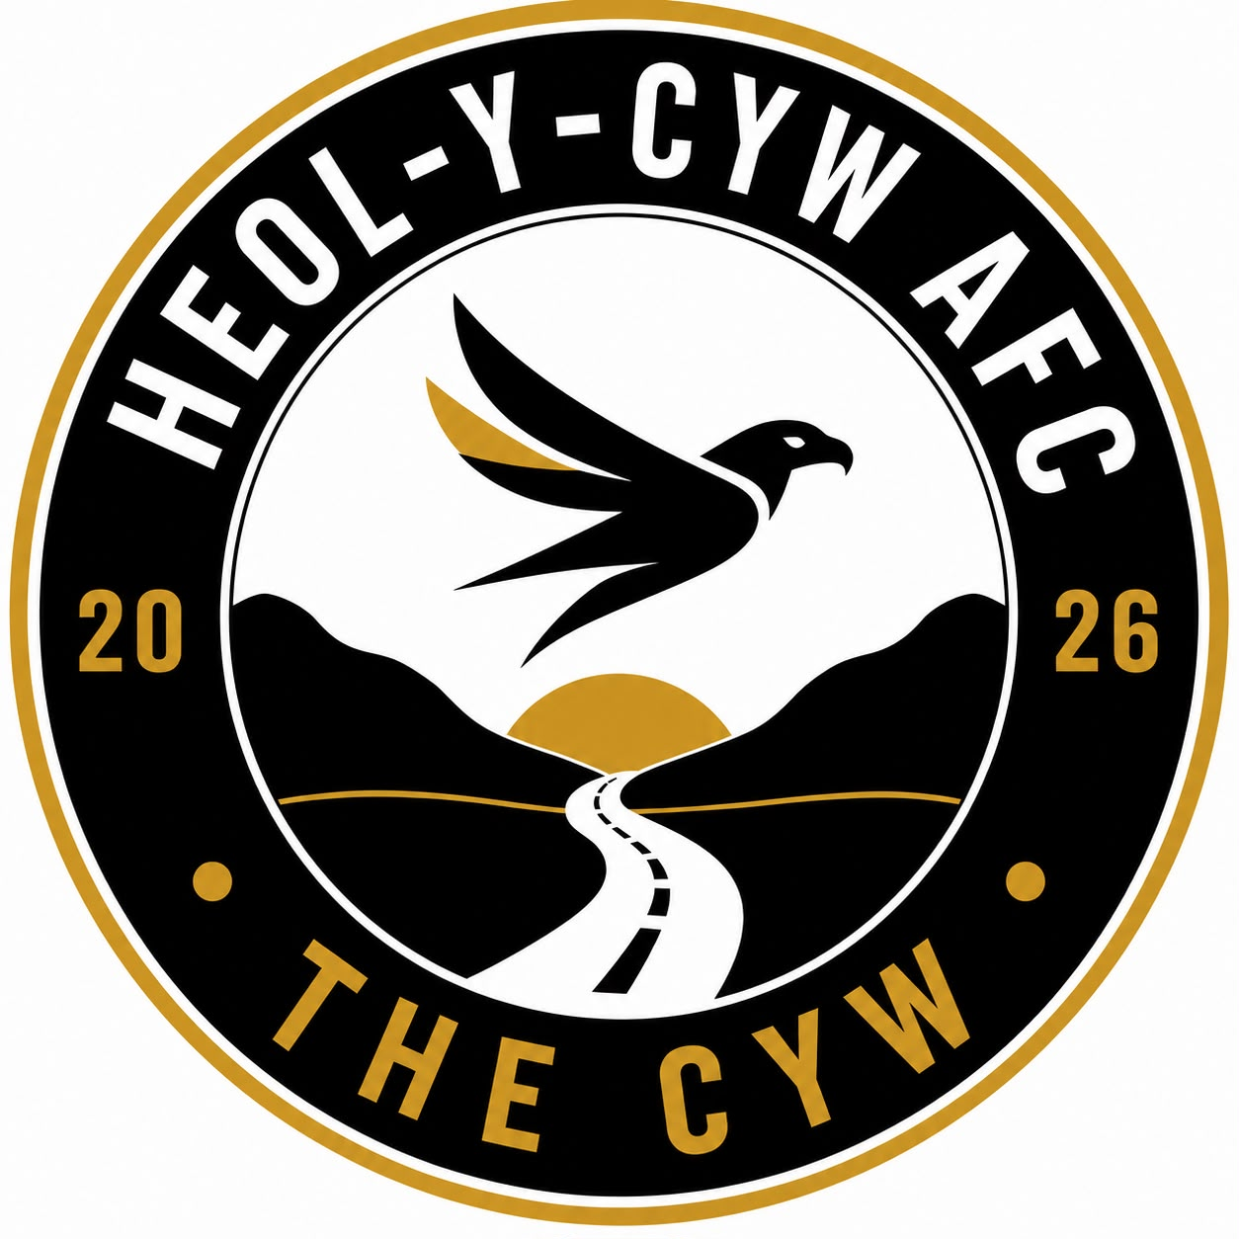
Safeguarding Policy
Heol-Y-Cyw AFC is committed to providing a safe, positive and inclusive environment for every child, young person and adult. Child-centred approaches are widely recognised as supporting children’s wellbeing, belonging and development by putting their needs at the centre of decisions. We believe every child deserves the opportunity to play, develop, enjoy the game, build confidence and create lifelong memories.
This policy applies to all players, coaches, volunteers, committee members, parents/carers, spectators, match officials, and visitors involved with the club.

Our Commitment
The club will:
- Promote the welfare and wellbeing of all children and adults at risk.
- Provide football in a safe, enjoyable and inclusive environment.
- Appoint a registered Club Safeguarding Officer.
- Ensure all coaches and volunteers complete the required FAW safeguarding training.
- Ensure all eligible individuals hold a valid Enhanced DBS check through the FAW before working with children.
- Adopt and enforce FAW Codes of Conduct.
- Operate a zero-tolerance approach to abuse, bullying, discrimination, harassment and poor practice.
- Respond promptly to all safeguarding concerns.
- Work in partnership with parents, carers, statutory agencies and the FAW.

Club Safeguarding Officer
The Club Safeguarding Officer (CSO) is responsible for:
- Promoting safeguarding throughout the club.
- Being the first point of contact for safeguarding concerns.
- Liaising with the FAW Safeguarding Team.
- Maintaining confidential safeguarding records.
- Ensuring safeguarding information is displayed and accessible.
- Supporting coaches and volunteers.
- Monitoring compliance with FAW safeguarding requirements.
- Ensuring all volunteers are DBS checked.

Recruitment and Safer Working Practice
The club will ensure:
- Appropriate recruitment procedures are followed.
- Role descriptions are issued.
- References are obtained where appropriate.
- FAW DBS checks are completed before unsupervised activity.
- Mandatory safeguarding training is completed.
- Coaches understand professional boundaries.
- Volunteers understand their safeguarding responsibilities.

Codes of Conduct
At Heol-Y-Cyw AFC we would expect all members to treat everyone with dignity and respect and to also promote equality and inclusion. We ask that you never engage in abusive, intimidating or discriminatory behaviour and to always use appropriate language. All concerns must be reported immediately.

Photography and Social Media
We will obtain parental consent where appropriate and we will use images responsibly. We will always encourage appropriate use of social media and will ensure communication with young players follow FAW guidance.

Anti-Bullying
Heol-Y-Cyw AFC believes that building friendships and confidence on and off the pitch are extremely important. The club has zero tolerance for bullying, cyberbullying, harassment, discrimination or victimisation. Any allegations will be investigated promptly.

Whistleblowing
Anyone who believes poor practice or abuse is occurring, then they should report it without fear of retaliation.

Confidentiality
Information will only be shared on a need-to-know basis to protect children or adults at risk and in accordance with UK GDPR and safeguarding legislation.

Equality, Diversity and Inclusion
Heol-Y-Cyw AFC welcomes participants regardless of age, disability, gender, race, religion or belief, sexual orientation, gender reassignment, pregnancy or maternity, marriage or civil partnership.
Discrimination will not be tolerated.

Safeguarding Training
The club will ensure:
- Safeguarding training remains current.
- New volunteers receive safeguarding induction and DBS checks.
- Committee members understand safeguarding responsibilities.
- Refresher training is completed when required by the FAW.

Reporting Safeguarding Concerns
Safeguarding children is everyone’s responsibility. If you are worried about a child, you must report your concerns; this should be to our Club Safeguarding Officer. If the concern is of a more serious nature, such as possible abuse, where possible, inform the Club Safeguarding Officer, and proceed to contact Social Services or the Police immediately.
The child’s welfare is paramount, ensure they are safe and if medical treatment is required, take them to hospital or call an ambulance and advise the doctor this is a child protection concern. If you are unable to contact our Club Safeguarding Officer or in a situation where the matter is clearly serious, contact either the FAW Safeguarding Officer, Police or Social Services, or NSPCC (details below).

Useful Contacts
In an emergency, where a child is at immediate risk of harm, call 999.
If you are worried about a child but it is not an emergency, the following contacts are available:
National Contacts
• FAW Safeguarding Team 029 20435830 Safeguarding@faw.cymru
• NSPCC Helpline – for anyone concerned about a child 0808 800 5000 https://www.nspcc.org.uk
• Childline – support for children and young people 0800 1111 https://www.childline.org.uk
• Live Fear Free (Wales) – 24/7 helpline for domestic abuse, sexual violence, and VAWG 0808 8010 800 https://gov.wales/live-fear free
• Dewis Cymru – online directory of wellbeing and safeguarding support services across Wales https://www.dewis.wales

Regional Safeguarding Boards in Wales
Safeguarding Boards bring together local authorities, health, police, probation, and other partners to protect children and adults at risk.
• Cardiff & Vale Regional Safeguarding Board https://www.cavrpb.org
• Cwm Taf Morgannwg Safeguarding Board https://www.ctmsb.co.uk
• Gwent Safeguarding Board https://www.gwentsafeguarding.org.uk
• Mid & West Wales Safeguarding Board https://www.cysur.wales
• North Wales Safeguarding Board https://www.northwalessafeguardingboard.wales

Club Safeguarding Officer for Heol-Y-Cyw AFC
Name: Leighan Davies
Email: heolycywafcsafeguarding@gmail.com

The club adopts the Football Association of Wales (FAW) Safeguarding Policy, Procedures, Welfare Regulations, and Codes of Conduct and will review this policy annually or following any legislative or FAW changes.

